**INTRODUCTION**  
**Project Title: FEE ACCOUNT SYSTEM**

**Project Description:**  
The **Fee Account System** is designed to streamline the management of student fee records in educational institutions. It ensures accuracy, transparency, and ease of tracking payments, dues, and financial reports. The system automates manual processes, supports real-time updates, and improves financial record-keeping efficiency.

**Team Members:**

* **Ahmed Irshad** – *Group Leader*
* **Sudais** – *Team Member*
* **Shayan** – *Team Member*
* **Khizar** – *Team Member*
* **Mashood** – *Team Member*
* **Kamran** – *Team Member*

**USE CASES:**Ahmed Irshad (Registration)  
Shayan Mughal (Submit Invoice)  
Sudais Murad (Process Payment)  
Hafiz Khizar (Generating Fee Receipt)  
Mashood Azam (Send Payment Reminder)  
Kamran Fiaz (View Payment History)

**CHAPTER 1: USE CASE DIAGRAM**  
AHMED IRSHAD (USE CASE DIAGRAM):

Use Case: Registration  
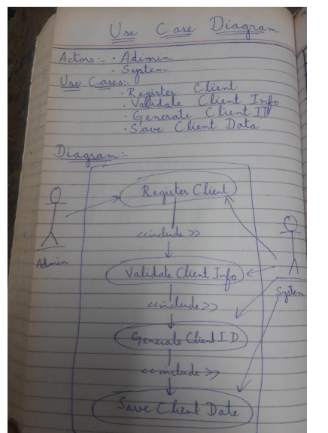

SUDAIS MURAD (USE CASE DIAGRAM):  
Use Case: Process Payment  
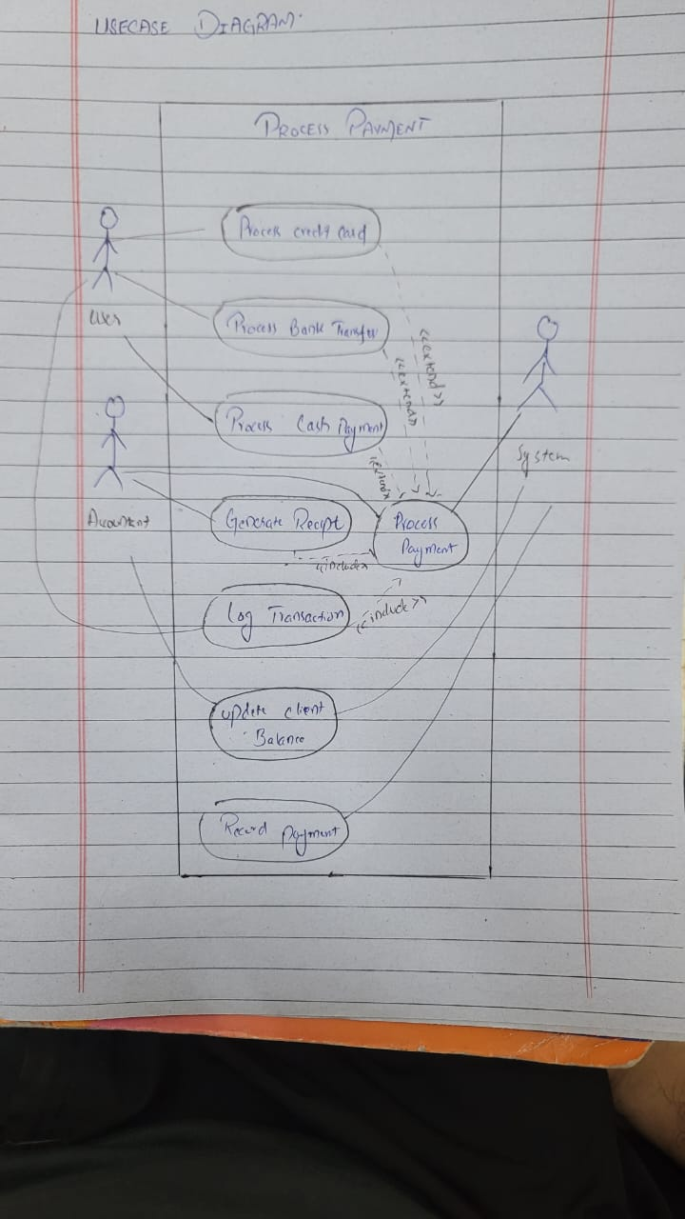  
  
  
  
  
  
SHAYAN MUGHAL (USE CASE DIAGRAM):  
Use case: Submit Invoice  
  
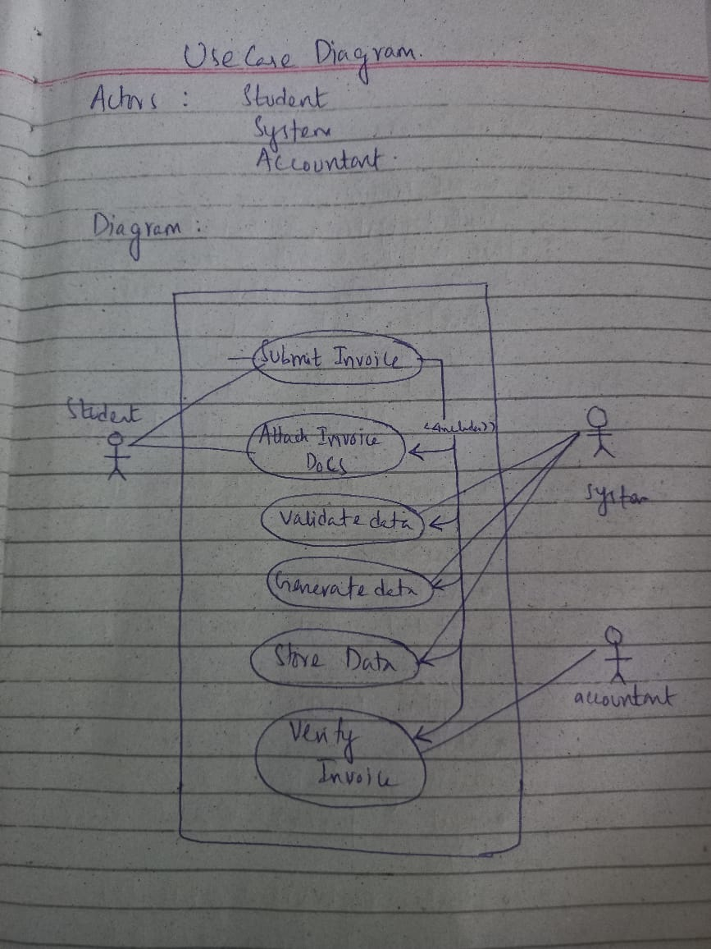

MASHOOD AZAM (USE CASE DIAGRAM):  
Use Case: Send Payment Reminder  
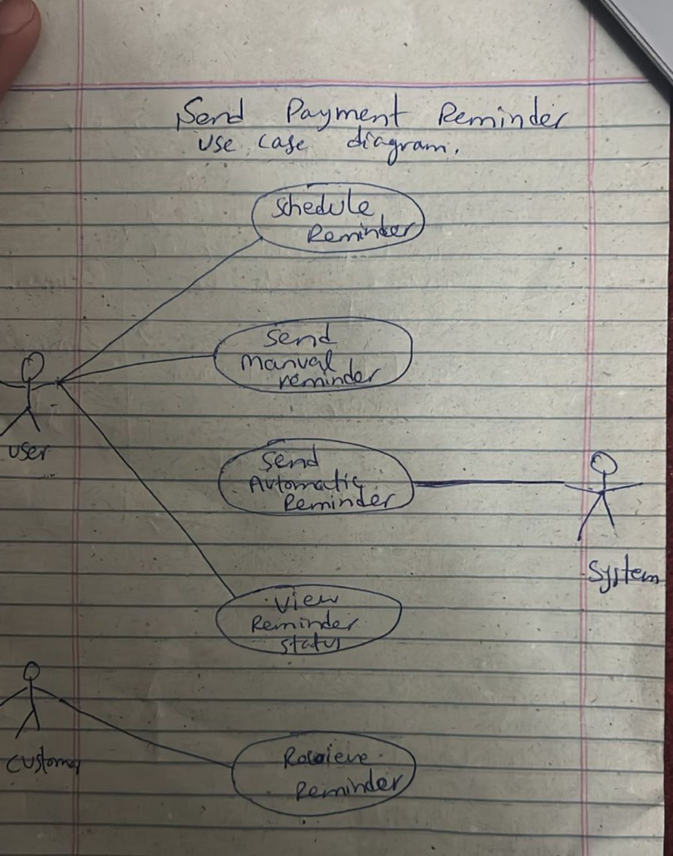

HAFIZ KHIZAR (USE CASE DIAGRAM):  
Use Case: Generate Fee Receipt  
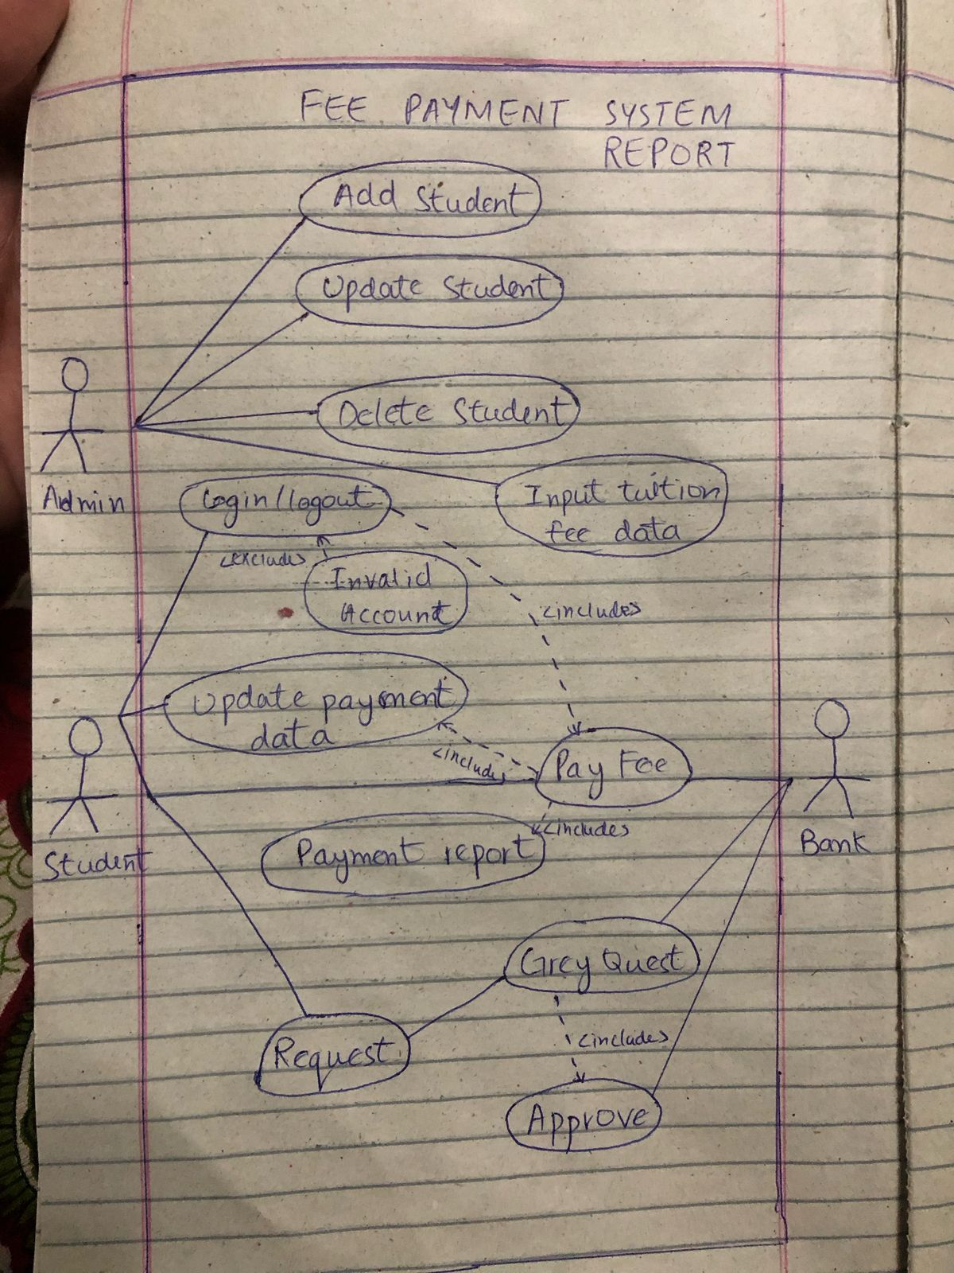

KAMRAN FIAZ (USE CASE DIAGRAM):  
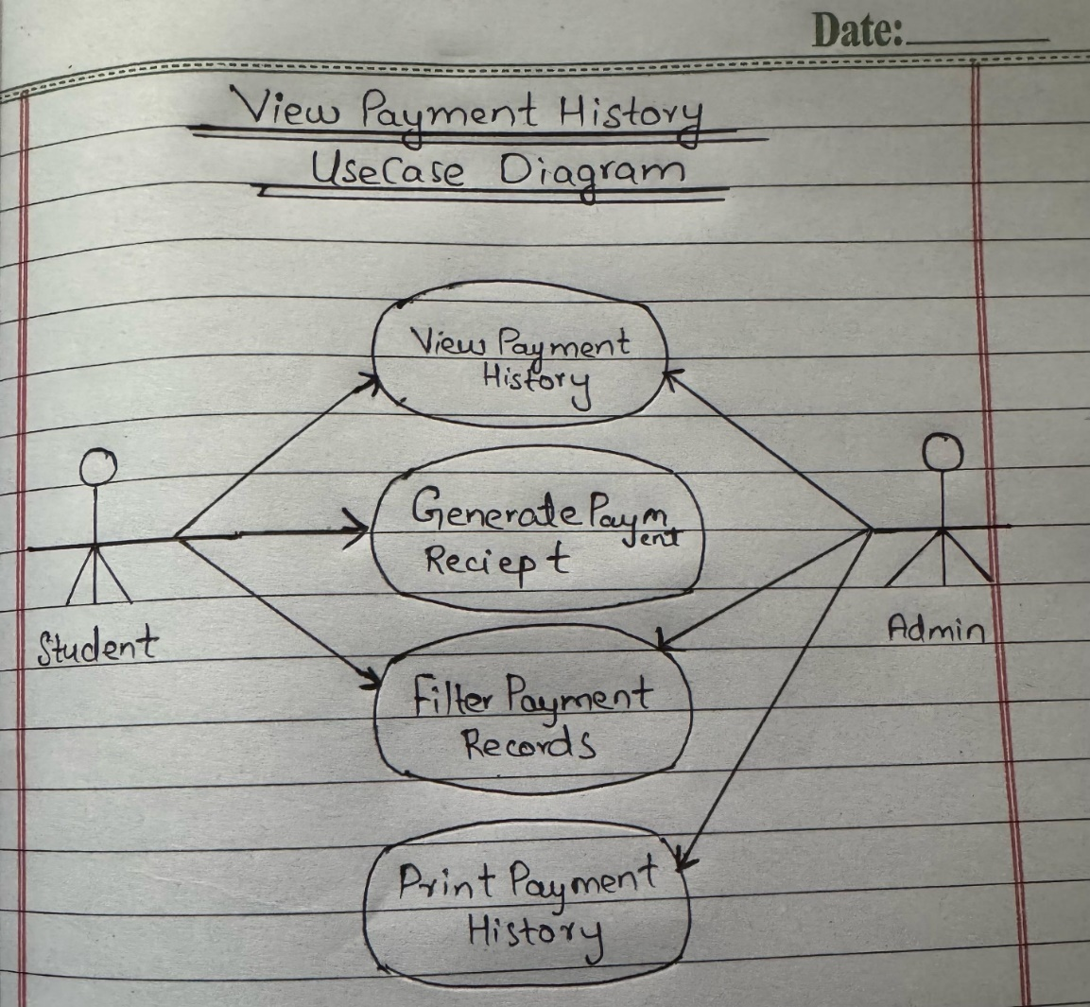

**CHAPTER 2: FULLY DRESSED USE CASE  
  
Ahmed Irshad:  
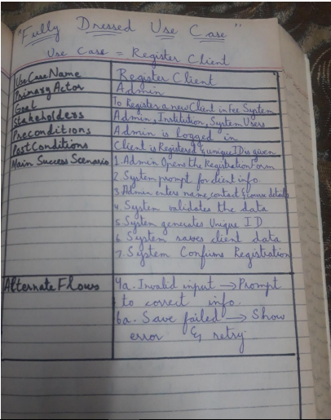**

SUDAIS MURAD:  
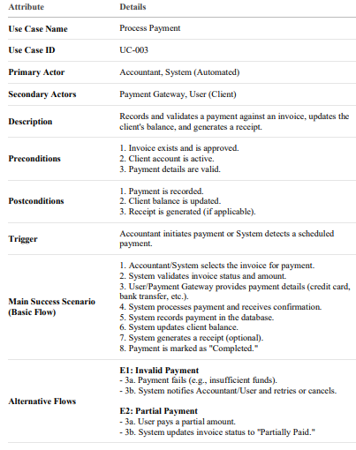

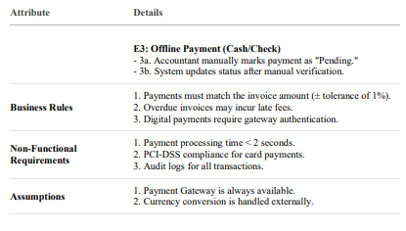

SHAYAN MUGHAL:  
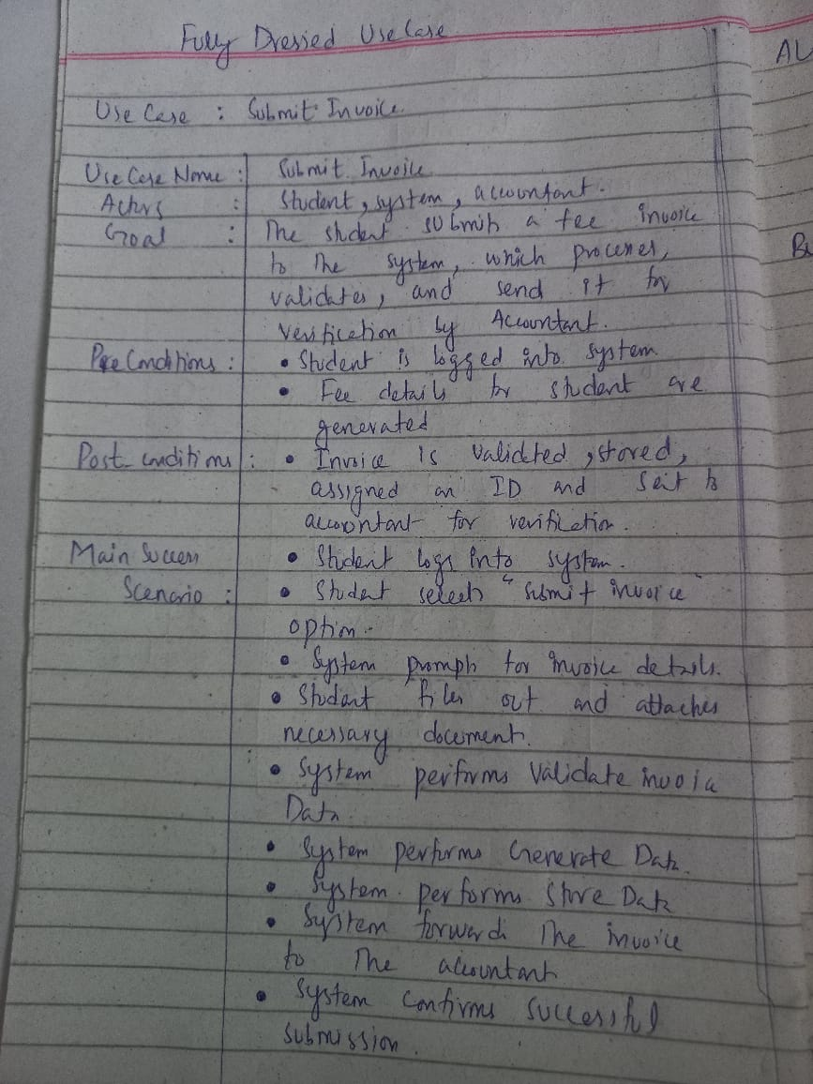

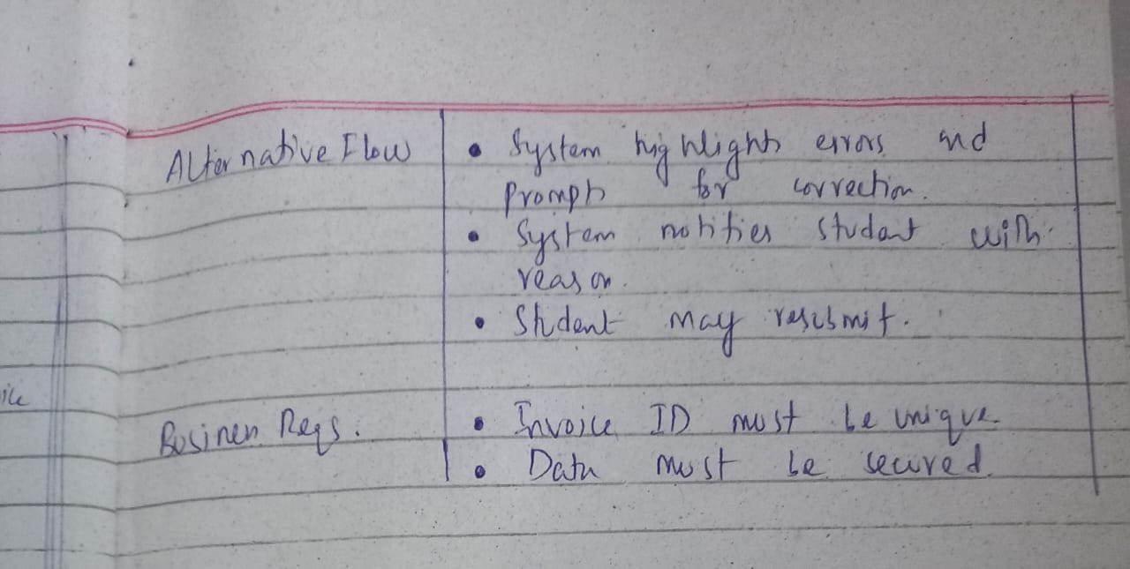

MASHOOD AZAM:

|  |  |
| --- | --- |
| Attribute | Details |
| Use Case Name | Send Payment Reminder |
| Scope | Payment Reminder System |
| Level | User Goal |
| Primary Actor | User (Admin or Staff) |
| Secondary Actor(s) | System, Customer |
| Stakeholders and Interests | - **User/Admin:** Wants to ensure customers are reminded of due payments. - **Customer:** Wants timely reminders to avoid penalties. - **System:** Automates reminders to reduce manual effort. |
| Preconditions | - The customer has a pending payment. - The due date is defined in the system. - Contact information (email/SMS) is available. |
| Postconditions | - The customer has received the reminder (email/SMS/notification). - Reminder status is updated in the system. |
| Main Success Scenario | 1. User logs into the system. 2. User selects a customer or invoice with a due payment. 3. User selects 'Send Payment Reminder.' 4. The system fetches customer contact details. 5. The system sends a reminder via the configured channel (email/SMS). 6. The system logs the reminder in the reminder history. 7. Customer receives the reminder. |
| Extensions (Alternative Flows) | 3a. Reminder is scheduled instead of sent immediately. 5a. Email/SMS server is unavailable → System retries or logs failure. 7a. Customer's contact info is invalid → System flags the error. |
| Special Requirements | - Reminder templates should be editable. - Multiple channels supported (Email, SMS, App). - System must support scheduling and recurring reminders. |
| Frequency of Use | Daily or as configured. |

HAFIZ KHIZAR:

|  |  |
| --- | --- |
| Use Case Name | Generate Fee Payment Report |
| Actor(s) | Admin, Accountant |
| Description | This use case allows the admin or accountant to generate a detailed report of student fee payments for record-keeping and analysis. |
| Trigger | The user selects the option to generate a fee report from the system interface. |
| Preconditions | The user must be logged into the system with appropriate privileges. |
| Postconditions | The system generates and displays/downloads the fee payment report. |
| Normal Flow | 1. User navigates to the reports section. 2. User selects 'Generate Fee Payment Report'. 3. User sets the desired filters (date range, student name, class, etc.). 4. System fetches relevant payment data. 5. System displays or allows download of the report. |
| Alternate Scenarios | 3a. No data available for selected filters:  - System shows 'No data found' message. |
| Special Requirements | The report must be exportable in PDF and Excel formats. |
| Frequency of Use | As required by the admin or accountant, typically monthly or on demand. |

**CHAPTER 3: SSDs**Ahmed irshad:  
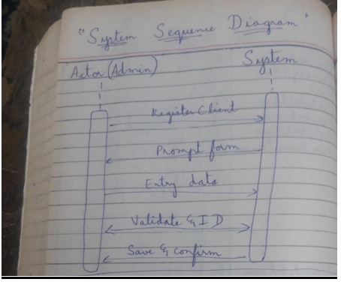

SUDAIS:  
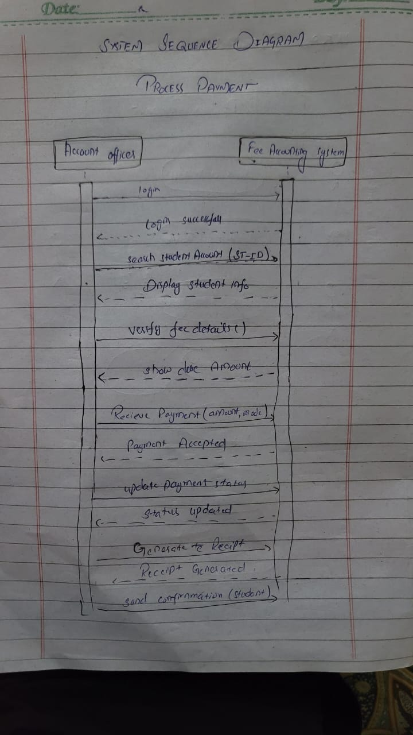

Shayan Mughal:  
  
  
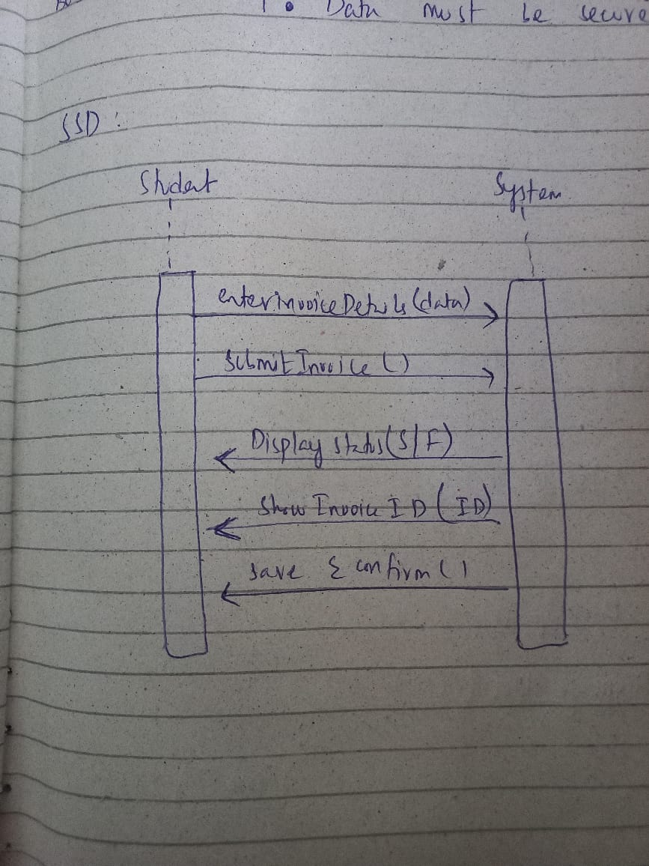

Chapter 1 Introduction 3

About the Project 3

Group Members 3

Chapter 2 Use Case Diagram 3

Chapter 3 Fully Dressed Use Cases 3

Haj Wali (SP23-BSE-064) 3

Login 3

Submit Proposal 3

Chapter 4 SSDs 4

# Chapter 1 Introduction

## About the Project

## Group Members

# Chapter 2 Use Case Diagram

# Chapter 3 Fully Dressed Use Cases

## Haj Wali (SP23-BSE-064)

### Login

### Submit Proposal

Zohaib (asdfs)

Assign Supervison

# Chapter 4 SSDs